


Simulation Course for ST3s

It’s the middle of the night and you are in charge….

Making decisions can be a real challenge…this course is designed to help you out

Work through challenging cases in a safe simulated clinical environment

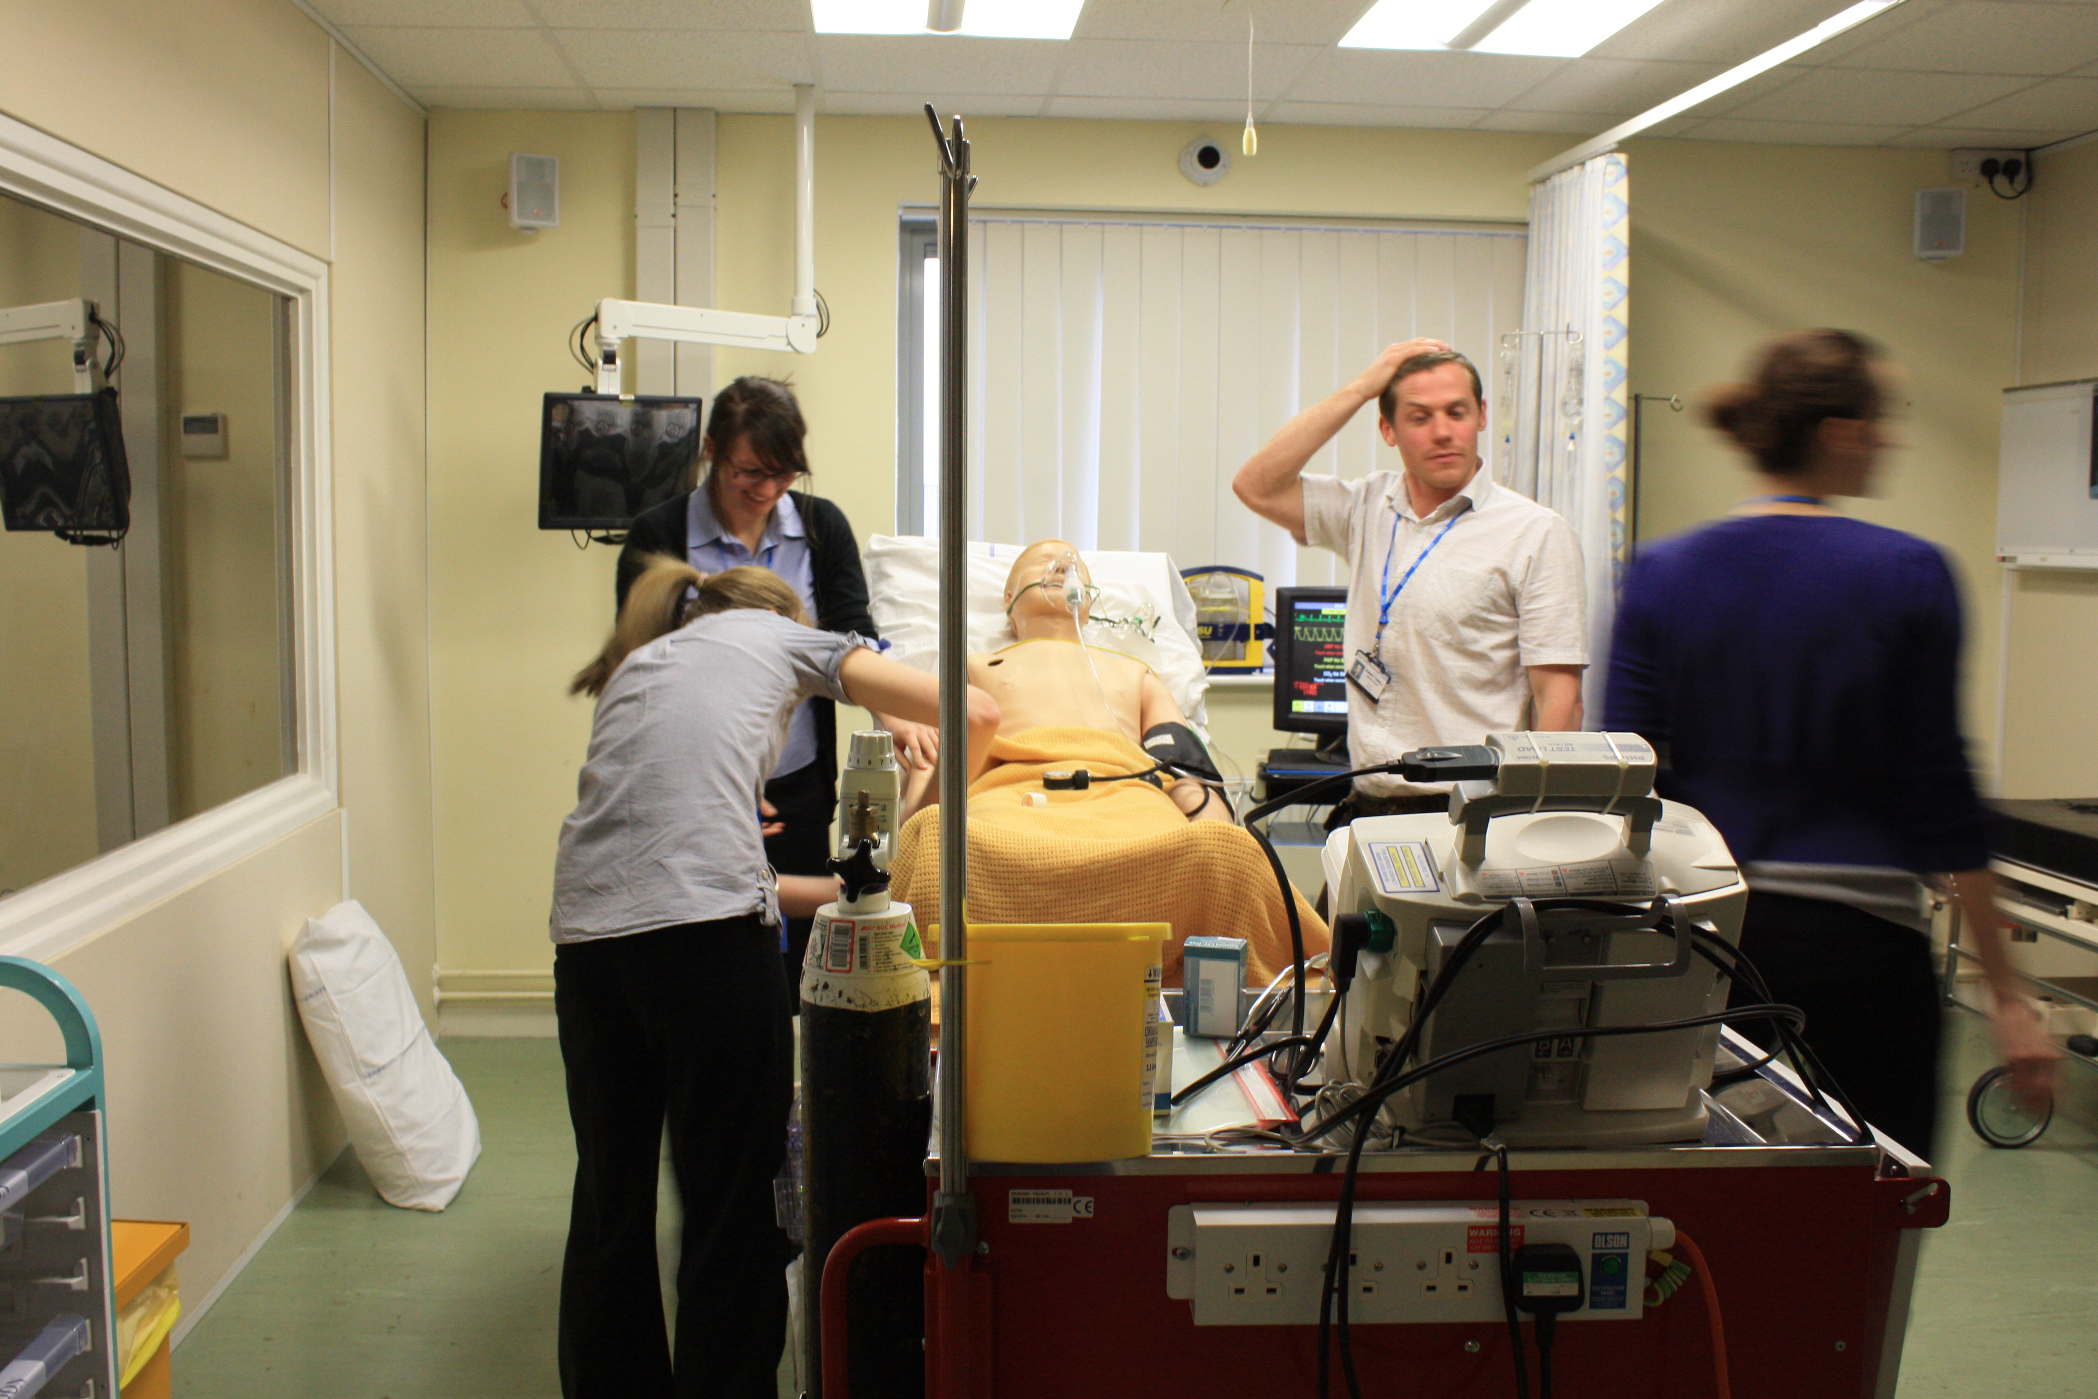

February 8th 2011 08:30 – 17:00 at the RUH

Limited spaces available (This is instead of regional training for ST3s)

Please fill in the attached application form and return by January 4th

Name____________________________________

I am an ST3 □

I am an ACCS trainee □

e-mail____________________________________

Phone___________________________________

Special dietary requirements______________________________

Please return to ismith6@nhs.net or Iain Smith, Royal United Hospital, Bath. BANES, BA1 3NG.

